MODA
MOdelling DAta providing a description
for the Full-Cell User Case
simulated in project NanoBat
OVERVIEW of the SIMULATION
1 | User Case | An inner cylider protrudes axisymmetrically into an outer metallic cylinder. The inner cylinder corresponds to anode and is made of carbon or similar. The outer cylinder corresponds to cathode ad is made of zinc or similar. The space between the two cylinders is filled with electrolyte. Additional cylindrical layers (separators) may be added by construction or formed during the electrochemical process.
2 | Chain of Models | Model 1 | Continuum Modelling of Materials: Electromagnetic Model (Maxwell Equations), reduced to Quasi-Electro-Statics at DC limit
 |  | Model 2 | Continuum Modelling of Materials: Heat Diffusion Equation, with source term due to power dissipated in electric field
 |  | Model 3 | Data-Based Model: electromagnetic and thermal parameters of materials, as a function of temperature (user data - not discussed in this MODA except for its coupling to Models 1 & 2)
3 | Publication Peer-Reviewing the data | To be filled at the later stage of the project.  [Please give the publication which documents the data of this ONE simulation. This article should ensure the quality of this data set (not only the quality of the models).]
4 | Access conditions | QWED will use their own FDTD commercial solver adapted to the modelling of coupled nonlinear EM-thermal probelms in cylindrical coordinates.  Part of the models and simulated results will be free.  The GUI and representative software versions dedicated to teaching and dissemination will be free (open access, but not open source).  Open Platform created in the NanoBat project (https://www.nanobat.eu/) will provide access to:  - the Models (CAD data files and results in Gwyddion format),  - Open GUI needed for examining and modifying the models as well as for visualising and analysing the computed results,  - dedicated FDTD solvers suitable for teaching and dissemination of major project results concerning the Models.  Commercial vendors should be contacted for full-power versions of FDTD solvers.
5 | Workflow and its rationale | The chosen user case is a representation of popular cylindrical batteries.  Model 1: will be used to compute the electric field in the entire structure by solving Maxwell equations. The main numerical result of the simulation will be the E -field everywhere in the structure. The obtained E- field is used to calculate time-averaged dissipated power patterns.  Model 2: will solve the thermal probelm, also linking the electric model to the thermal model, feeding dissipated power as a source term into the heat diffusion equation.  Model 3: will couple the thermal model back to the electric model, introducing temperature variation of the material parameters. It will also introduce the nonlinearity into the thermal model.

User Case Parameters
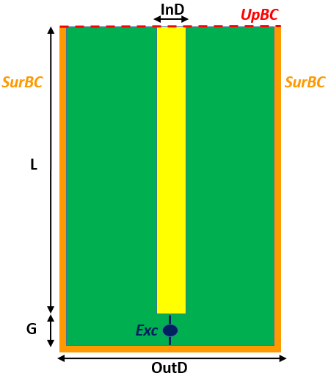
Fig. 1. Cross-section of the half-cell structure.
Table 1. Parameters of the full-cell User Case.
Parameter | Meaning | Value/values range | Comment
InD | Diameter of inner conductor | tbd
OutD | Diameter of outer conductor | 18 mm | Computation domain size
L | Length of inner conductor | 65 mm
G | Separation gap between the inner and outer conductors | tbd
UpEmBC | Upper electromagnetic boundary condition | PMC
SurEmBC | Outer (side and bottom) electromagnetic boundary condition | PEC
UpThBC | Thermal boundary condition at upper boundary | Explicit (Dirichlet)  or Robin
SurThBC | Thermal boundary condition at outer (side and bottom) boundary | Explicit (Dirichlet)  or Robin
InThBC | Thermal boundary condition at inner conductor boundary | Robin
medOUT | Medium of the outer conductor | Zinc or similar
medIN | Medium of the inner conductor | graphite or similar
medE | Medium of the electrolyte | Dielectric constants: ε_{r}; tanδ.  diethyl carbonate (DEC)  ε_{r} = 2.82 [Wohlfarth, C. Permittivity (Dielectric Constants) of Liquids. In  CRC Handbook of Chemistry and Physics (Internet Version 2015)]  dimethyl carbonate (DMC)  ε_{r}= 3.08 [W. M., Ed.; CRC Press/Taylor and Francis: Boca Raton, FL,  2015; pp 6-187−6-208.]  ethyl methyl carbonate (EMC)  ε_{r} = 2.9 [McEwen, A. B. et. al; Electrochem. Soc. 1997,  144 (4)]  dimethoxyethane (DME)  ε_{r} = 7.2 [Ue, M, et. al.,  J.Electrochem. Soc. 1995, 142 (8), 2577−2581]  Note: Dielectric constant values are obtained at room temperature 25°C | To be selected during the project.  Literature search needed for temperature dependence of material parameters.
Problem type |  | BOR
Exc | Excitation | Voltage source
Freq | Frequency of analysis | DC to 10 GHz
Requested output |  | Heat/temperature distribution

Workflow

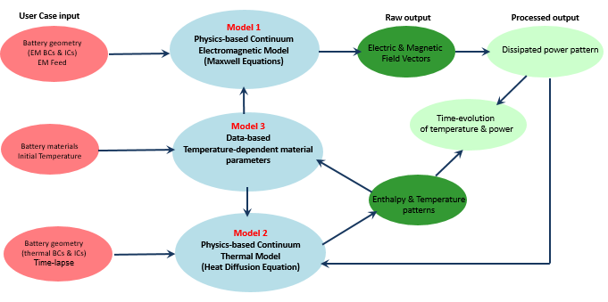

MODEL 1
Electromagnetic Analysis in Time- Domain
1 | Aspect of the User Case/System to be Simulated
1.1 | Aspect of the User Case to be simulated | Compute the E- field (and H- field for full-wave Maxwell) of the entire structure for a given excitation at the input port (the gap between the two cylinders)
1.2 | Material | See figure and table for materials of the test fixture and environment
1.3 | Geometry | See figure and table
1.4 | Time Lapse | The chosen frequency range is DC to 10GHz. At each “thermal” iteration, a new EM steday state is recahed, whcich typically requires several to 100 periods of the source signal.
1.5 | Manufacturing process or  in-service conditions | N/A
1.6 | Publication on this data | Papers are foreseen at the later stage of the project.

2 | Generic Physics Of The Model Equation
2.0 | Model type and name | Continuum Modelling of Materials: Electromagnetics
2.1 | Model entity | Finite volumes (conformal cells)
2.2 | Model Physics/ Chemistry equation  PE | Equation | Maxwell equations (full-wave or in quasi-electro-static approximation)
 |  | Physical  quantities | spatial coordinates (3 scalars), time (scalar)  space- and time-dependent:  E-field, H-field (vectors), dissipated power (scalar), magnetic permeability, electric permittivity, electric conductivity (scalars or diagonal tensors).
2.3 | Materials relations | Relation | $\vec{D}=ε\vec{E}$, $\vec{B}=μ\vec{H}$, $\vec{J}=σ\vec{E}$
 |  | Physical quantities/  descriptors for each MR | The values $\left(μ,ε,σ\right)$ are obtained by own measurements or taken from the available literature.
2.4 | Simulated input | N/A

3 | Solver and Computational translation of the specifications
3.1 | Numerical Solver | FDTD
3.2 | Software tool | QuickWave (enhanced in the project)
3.3 | Time step | taken according to the FDTD stability condition
3.4 | Computational Representation | Physics Equation, Material Relations, Material | no special computer representation - physical quantities directly modelled (scaled for convenience)
3.5 | Computational boundary conditions | The computational domain should be surrounded by a cylindrical boundary condition (PEC, PMC or ABC); see figure
3.6 | additional Solver Parameters | - Stability limit for the given mesh; time lapse to achieve converged computed result

4 | POST PROCESSING
4.1 | The processed output | The E-field (and H-field for full Maxwell) vectors in each element of the mesh are directly obtained.
4.2 | Methodologies | dissipated power calculated internally, based on definition  E-field is integrated to approximate local voltages.  FDTD followed by Discrete Fourier Transformation to obtain frequency-domain voltages and currents
4.3 | Margin Of Error | to be discussed in future publications

MODEL 2
Thermodynamic Analysis in Time- Domain
1 | Aspect of the User Case/System to be Simulated
1.1 | Aspect of the User Case to be simulated | Compute temperature distribution of the entire structure, taking into account heat generation (by electric field) and heat diffusion
1.2 | Material | See figure and table for materials of the test fixture and environment
1.3 | Geometry | See figure and table
1.4 | Time Lapse | Steady-state solution: Time needed to reach thermal steady state (material- and process-dependent)  Transient solution: time-lapse of interets to the user
1.5 | Manufacturing process or  in-service conditions | N/A
1.6 | Publication on this data | Papers are foreseen at the later stage of the project.

2 | Generic Physics Of The Model Equation
2.0 | Model type and name | Continuum Modelling of Materials: Thermodynamics
2.1 | Model entity | Finite volumes (conformal FDTD cells)
2.2 | Model Physics/ Chemistry equation  PE | Equation | Heat diffusion (with source term)
 |  | Physical  quantities | Spatial coordinates (3 scalars), time (scalar)  spce- and time-dependent:  dissipated power and temperature (scalars),  thermal flux (vector), thermal conductivity k (scalar or diagonal tensor), specific heat c_{p} and density ρ (scalars).
2.3 | Materials relations | Relation | $\vec{Q}=-k grad T$ dT/dt = -div $\vec{Q}$/c_{p}ρ+P
 |  | Physical quantities/  descriptors for each MR | The values are obtained by own measurements or taken from the available literature.
2.4 | Simulated input | dissipated power distribution from Model 1

3 | Solver and Computational translation of the specifications
3.1 | Numerical Solver | FDTD
3.2 | Software tool | QuickWave (enhanced in the project)
3.3 | Time step | taken according to the stability condition.
3.4 | Computational Representation | Physics Equation, Material Relations, Material | no special computer representation - physical quantities directly modelled (scaled for convenience)
3.5 | Computational boundary conditions | The computational domain should be surrounded by a cylindrical boundary condition (Dirichlet or Robin); see figure
3.6 | additional Solver Parameters | - N/A

4 | POST PROCESSING
4.1 | The processed output | export temperature distribution to Model 3, which then returns thermal material parameters to this Model 2 and exports electromagnetic material parameters to Model 1
4.2 | Methodologies | internal data exchange  material data built-in or in external text-files
4.3 | Margin Of Error | to be discussed in future publications

