MODA
MOdelling DAta providing a description
for the Full-Cell User Case
simulated in project NanoBat

OVERVIEW of the SIMULATION
1 | User Case | The user wants to simulate Li-ion batteries typically used in electric vehicles such as 18650 NMC cells, see Fig. 1. Showing the geometry and typical cell components. An appropriate equivalent electric circuit (EEC) model can be developed to describe the electrochemical reaction that takes place at the electrode/electrolyte interfaces, both on anode and cathode. The purpose of the simulation is to extract electrical circuit models of battery cells and characterize the behaviour of the cell and simulate the impedance and its relation to different parameters such as state of charge (SoC) and temperature (T).  This data-based model requires a series of spectra to be collected under different conditions from experimental measurements including electrochemical impedance spectroscopy, SoC versus high and low current loads, and temperature dependences.  Samples under test consist of battery full-cells: type 18650 (18mm by 65mm) that consist of an SEI formed battery, installed in a special home-made connection and safety fixture, prepared with 4-wire kelvin connectors to extract accurate and calibrated measurement data which is fed into an equivalent electric circuit model to be parameterized.
2 | Chain of Models | DATA-BASED Model | Electronic model: Equivalent electric circuit model of a Li-ion battery, using distributed parameters, that includes constant phase elements (CPE), Warburg elements, as well as inductors and resistors.
3 | Publication Peer-Reviewing the data | Working title of planned publication: “Modelling Batteries from Electro-Impedance Spectroscopy Data”.  - Supporting references:  - Keysight Technologies Impedance Measurement Handbook: A guide to measurement technology and techniques, 6th Edition, 2016, 140 pages, Nr. 5950-3000  - Andrzej Lasia, ‘Electrochemical Impedance Spectroscopy and its Applications’, Springer, 2014.
4 | Access conditions | Keysight will apply equivalent circuit modelling. The data will be made available under license type CC BY.
5 | Workflow and its rationale | The chosen user case is a popular type of secondary cylindrical batteries of high importance in the energy domain, with a large field of applications.  The equivalent circuit topology used to model Li-ion battery is defined according to the physical interphases in the battery, while the circuit parameters are acquired empirically through simulations and experiments. The information provided by the impedance spectroscopy experiments represents the key role for data modelling. Proper electrochemical interpretation of the model circuit elements/blocks and their associated parameters implicitly places constraints on the admissible numerical values for the model parameters.  For fast speed computations, pre-existing solvers are used (e.g. MATLAB, ADS software of KEYS) allowing to use this model directly in production to decide real-time on cell quality and performance parameters.
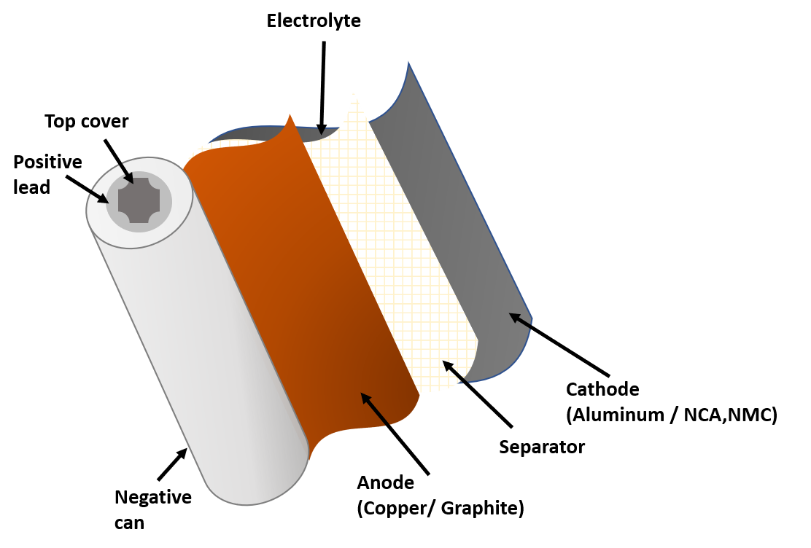
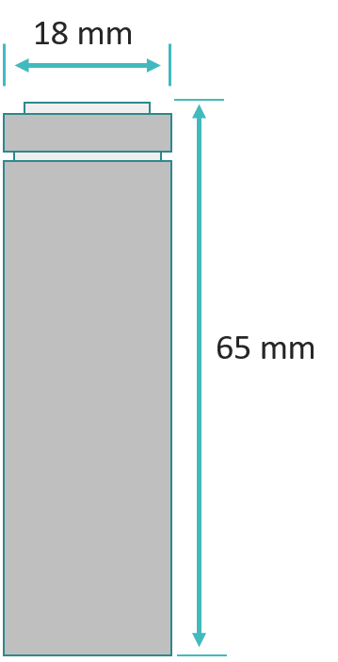
User Case Parameters
(b)
(a)

Fig. 1. Outer dimensions of an 18650 Li-ion cell (a), inner cell structure showing the roles of anode, cathode and separator and their materials (b).

Equivalent Electric Circuit Topology

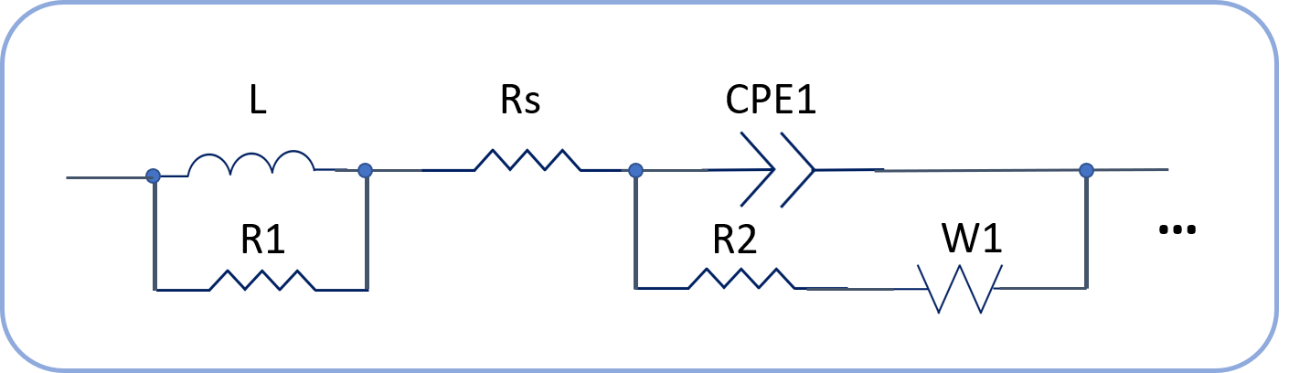

Fig. 2. Main elements used in the equivalent electric circuit model

Workflow
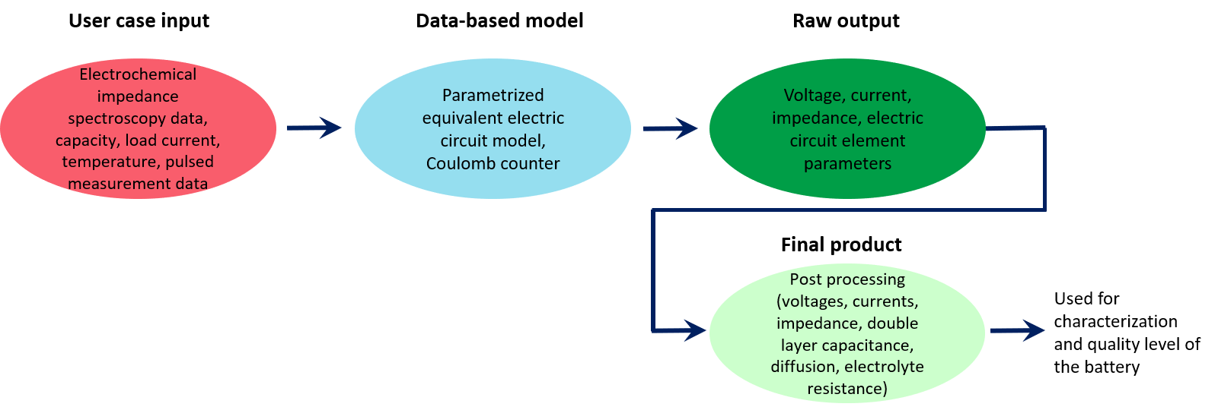

Data-Based Model
Equivalent electric circuit model with electrochemical interpreted elements

 | Aspect of the User Case/System to be Simulated
1.1 | Aspect of the User Case to be simulated | To perform simulation of Li-ion batteries. The electric circuit model topology aims to provide a good mapping between circuit parameters and electrochemical parameters. To analyse and characterize battery behaviour based on the electrochemical impedance spectroscopy data. The output can ber further prosessed to provide valuable classification of state of charge, or state of health of batteries.
1.2 | Material | Bulk battery full-cells: types 18650 (18mm by 65mm, see Fig.1), or 21700 (21mm by 70mm). Battery is attachment to sample holder (a fixture) is done typically with spring connectors, or different types of alligator or insulated ring connectors. The model considers the inductive effect of wires and connectors to the battery.  See figure and table for different parts and materials of the bulk battery used in experiments to provide input data for the data-based model.
1.3 | Geometry | See figure 1 above.
1.4 | Time Lapse | Time lapse varies depending on the modelled circuit topology, the required parameters to be extracted, as well as the number of data points simulated. The time lapse can vary from a few seconds up to several minutes.
1.5 | Manufacturing process or  in-service conditions | Voltage bias, current, temperature
1.6 | Publication on this data | Working title of planned publication: “Modelling Batteries from Electro-Impedance Spectroscopy Data”.

2 | Generic Physics Of The Model Equation
2.0 | Model type and name | Data-Based Model of Battery: Electric equivalent circuit model and relation to physical parameters
2.1 | Model entity | Finite volumes
2.2 | Model Physics/ Chemistry equation  PE | Equation | Circuit-theory  Impedance, fractional-order capacitance, inductance, capacitance, Warburg diffusion  Resistor impedance R  Inductor impedance 2πfL  Capacitor impedance 1/2πfC  Warburg impedance R_{D}ct tanh$\left(\frac{Ϭ}{\sqrt{D}}\sqrt{j2πf}\right)$  Constant phase element impedance:  $Z_{cpe}=\frac{1}{{Y_{CPE}\left(jω\right)}^{P_{CPE}}}$
 |  | Physical  quantities | R resistance  T absolute temperature  V interface potential  R_{D} diffusion resistance  Ϭ Thickness of the diffusion layer  D diffusion coefficient  f frequency of excitation signal  j complex variable  $Y_{CPE}$ capacitance of CPE  $P_{CPE}$ exponent of CPE
2.3 | Materials relations | Relation
 |  | Physical quantities/  descriptors for each MR | Temperature  State of charge  Capacity, Charge
2.4 | Simulated input | EIS simulated data can be used as input for model verification. Data-Based model uses experimental EIS data as input.

3 | Solver and Computational translation of the specifications
3.1 | Numerical Solver | MATLAB solvers
3.2 | Software tool | MATLAB, ADS Keysight
3.3 | Time step | Equivalent electric circuit fitting process.
3.4 | Computational Representation | Physics Equation, Material Relations, Material | no special computer representation - physical quantities directly modelled (scaled for convenience)
3.5 | Computational boundary conditions | Electric circuit components are bounded in order to maintain real physical interpretation of battery physical-chemical properties.
3.6 | additional Solver Parameters | Number of equivalent circuit blocks to be modelled.

4 | POST PROCESSING
4.1 | The processed output | The output is post processed to determine physical quantitates such as double layer capacitance, diffusion constant, electrolyte resistance.
4.2 | Methodologies | Based on mathematical relations to map the circuit elements into physically meaningful parameters.
4.3 | Margin Of Error | to be discussed in future publications.

